

**ASSIGNMENT 9**

[Design a **4-BIT UP/DOWN RIPPLE COUNTER**]



**NAME: ROHIT SADHU**

**ROLL NO.: 002010501074**



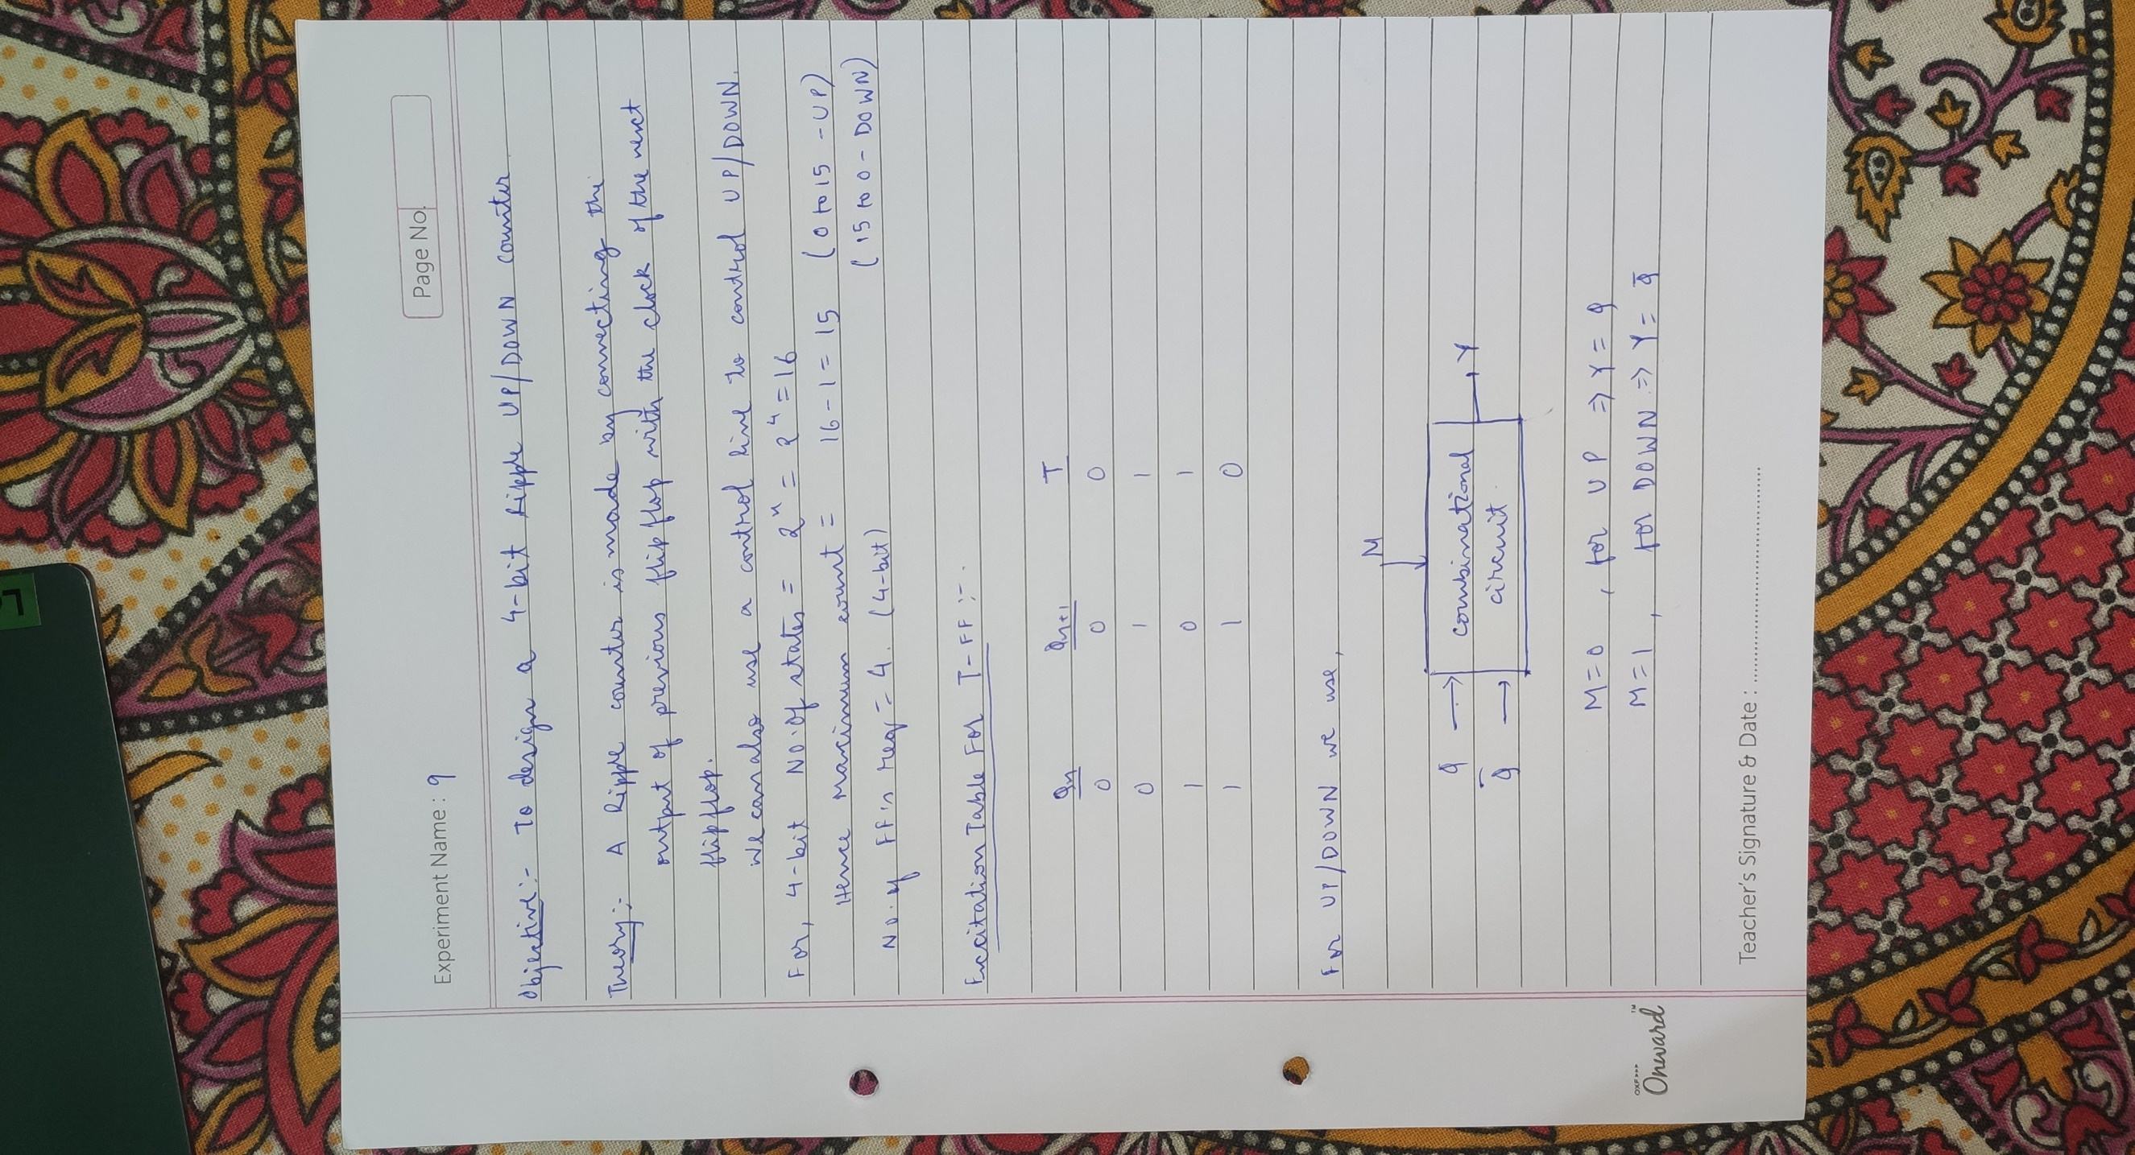

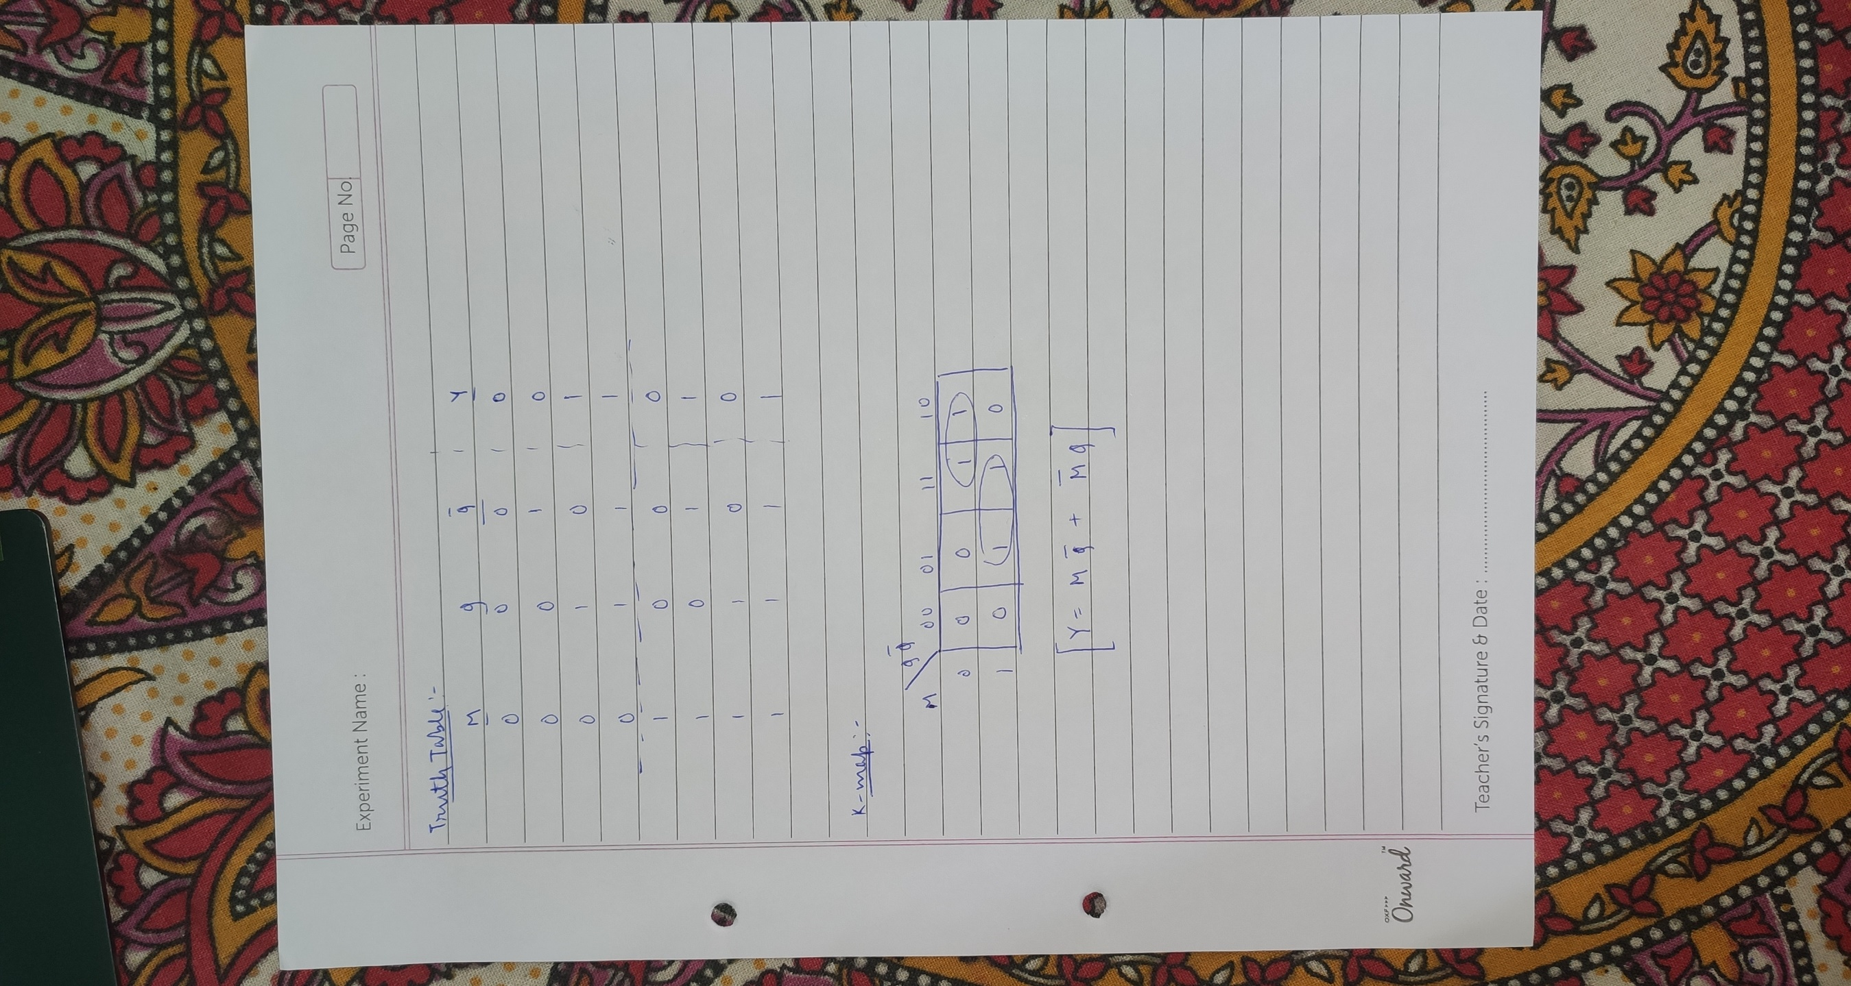

**CIRCUIT DIAGRAM:**

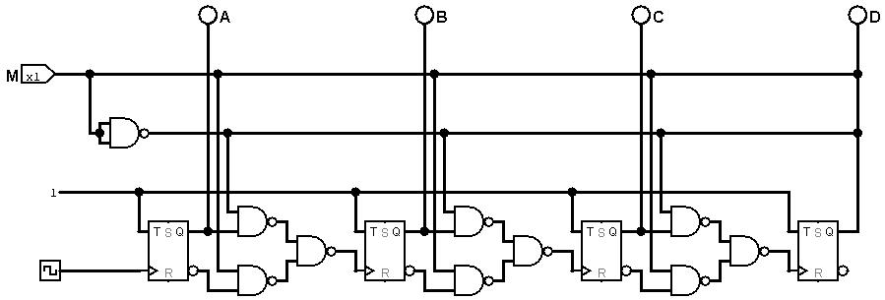**UP/DOWN RIPPLE COUNTER:**

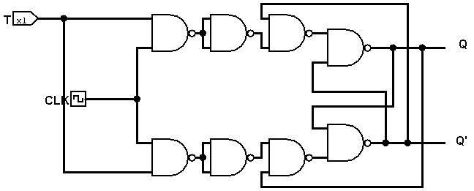**T – FF:**